NORTH BRADLEY PARISH
COUNCIL (INCORPORATING BROKERSWOOD, NORTH BRADLEY AND YARNBROOK)

Neighbourhood Plan – Possible Sites for Homes –
Your Comments Wanted, bring this form to a
Consultation at North Bradley Baptist Church on
Friday 16 March 5.30 – 7.30 p.m and
Saturday 17 March 10.00 – 12.00 a.m & 2.30- 4.30 p.m
Or if you are not able to attend return the completed form by 17 March 2018 to
12 Churchlands, North Bradley, BA14 0TD. Or e-mail to parishcouncil@northbradley.org.uk
As part of the community’s emerging Neighbourhood Plan, Regulations require us to consider the matter of housing in North Bradley. We cannot ignore the needs of an increasing and changing population. Many of you were kind enough to respond to the Housing Needs Survey and we expect to receive an analysis back from Wiltshire Council shortly, which we will then be able to share with the community. We have had to search carefully for where some homes could be built to the least detriment to the Parish and at the most appropriate sites for the potential occupiers.
Sites have to be considered against a number of criteria, including whether the community would support them or not. We have had to consider all the sites that so far have been considered by Wiltshire Council and one at Organ Pool Farm, which has just been proposed by a developer. Nothing has yet been decided, but a Site Selection Report has been produced with the assistance of our planning consultant who is advising the community. The report is online at:
http://www.northbradley.org.uk/index.php/en/parish-council and from the Parish Council e-mail parishcouncil@northbradley.org.uk
The report analyses the various sites proven to be available and recommends that our Neighbourhood Plan takes forward just one of them, delivering housing to meet local needs only as shown in the recent Housing Needs Survey. Although it is unlikely that any housing beyond the sites indicated on this form will need to be considered to meet local needs, anyone in the community is free to put forward alternative sites to those shown here, IF these are accompanied by a good quality map showing the site boundary in red and written confirmation from the landowner that the site is available for sale or development.
The purpose of this short questionnaire is to seek your views on housing in North Bradley that can be delivered through the Neighbourhood Plan and your comments on the various sites indicated. Your responses will be used to create a ‘Regulation 14’ consultation draft plan which will then go out to all the community for a further 6 - weeks consultation in the late Spring or early Summer
Nothing has yet been decided, but a Site Selection Report has been carried out. The report is online at: http://www.northbradley.org.uk/index.php/en/parish-council
and from the parish council parishcouncil@northbradley.org.uk

1. Housing Supply in North Bradley:

a. Do you think that more housing is needed to meet local needs – for
example young people and others who cannot afford local prices?

Yes No

To meet the needs of the open market?

Yes No

2. If new housing is to be created within the parish, how much
should be allowed between now and 2026? Please tick.

a. None b. 1-10 homes

c. 11-50 homes d. 51-200 homes

e. More than 200.

3. What type of housing is most needed? (please state)

-----------------------------------------------------------------------------------------------------------------------------------------------------------------------------------------------------------------------------------------------------------------------------------------------------------------------------------------------------------------------------------------------------------------------------------------------------------------------------------------------------------------------------------------------------------------------------------------------------------------------------------------------

3. Please score the sites out of 10, 10 being the one(s) you most
approve of, and 1 being those you approve of the least.
See map on next page for their locations.
SHELAA No: 298 South / south-west of Trowbridge
(HSAP Site H2.2 ‘Land off A 363 off White Horse Business Park’

SHELAA No.: 322 Park Farm

SHELAA No.: 613 Land south / south-west of
Trowbridge (HSAP Site H2.1 ‘Elm Grove Farm’)

SHELAA No.: 672 Paddock at Little Common Lane

SHELAA No.: 1040 54 Woodmarsh

SHELAA No.: 3565 ‘Southwick Court’
(HSAP site H2.6) Land South of Trowbridge

N/A Organ Pool Farm, Southwick Road, North Bradley

NOTE: Our neighbourhood plan cannot block the ‘HSAP’ sites and will NOT be allocating them – these will be taken forward through a separate process run by Wiltshire Council. However, we include them here in order to get your opinions. The sites in blue type above could be allocated by the neighbourhood plan or a future revision. Nevertheless, please score all sites.

4. Please add any comments you have on any of the sites including
any conditions that should be applied if they are to be allocated.
Please try to keep comments concise.

-------------------------------------------------------------------------------------------------------------------------------------------------------------------------------------------------------------------------------------------------------------------------------------------------------------------------------------------------------------------------------------------------------------------------------------------------------------------------------------------------------------------------------------------------------------------------------------------------------------------------------------------------------------------------------------------------------------------------------------------------------------------------------------------------------------------------------------------------------------------------------------------------------------------------

5. Do you have any other sites you would like considered?
NOTE: Only sites that are accompanied by an O/S based map
drawn with a clear and accurate red site boundary AND written
confirmation from the landowner that they are available for sale
will be accepted.
---------------------------------------------------------------------------------------------------------------------------------------------------------------------------------------------------------------------------------------------------------------------------

6. Do you have any other comments on housing in North Bradley?
(Note: you will be consulted again during the formal 6-week ‘Regulation 14’ Consultation).

-----------------------------------------------------------------------------------------------------------------------------------------------------------------------------------------------------------------------------------------------------------------------------------------------------------------------------------------------------------------------------------------------------------------------------------------------------------------------------------------------------------------------------------------------------------------------------------------------------------------------------------------------

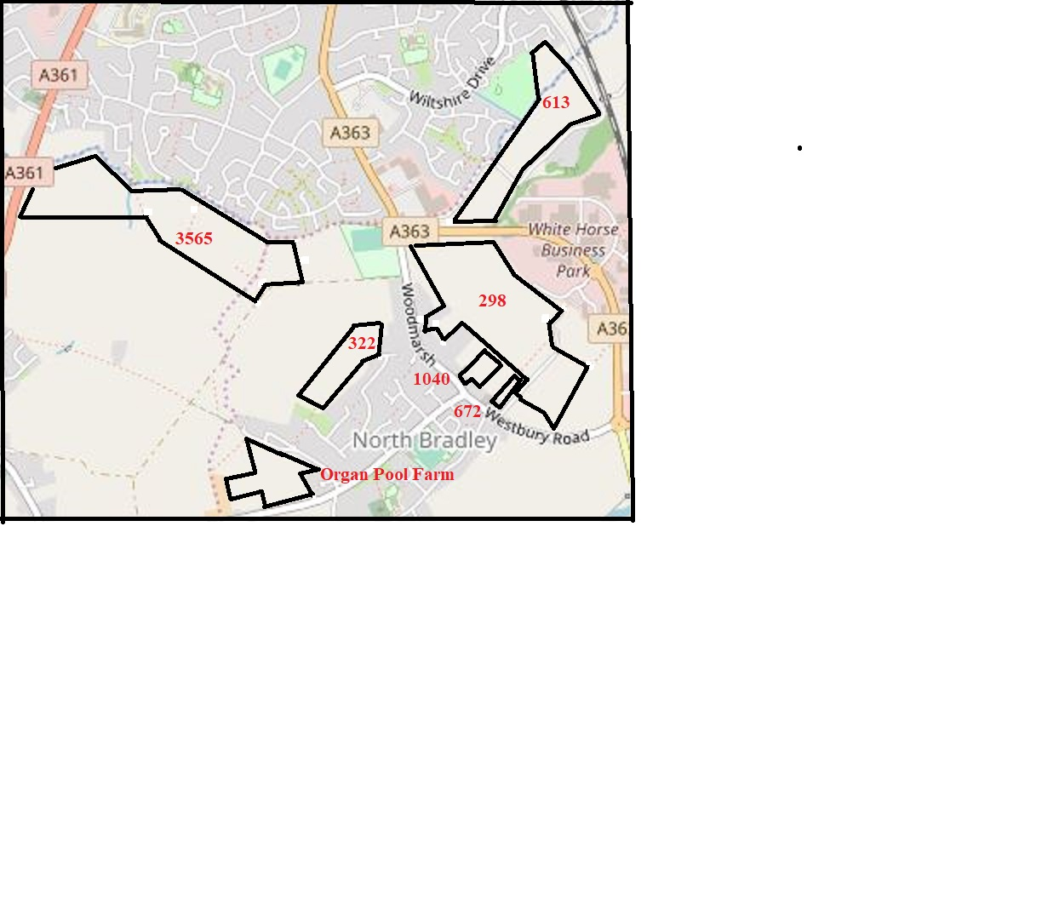

(N.B Parish Council – Feb.2018)
Obtained from Open Street Map

